<$ScrKeepWithNext><$Scr_H::2><$Scr_Ps::0>
Reader
<!$Scr_H::2><!$Scr_Ps::0>
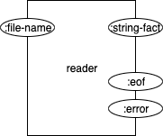
Figure <$n:figure:Reader>

The reader Part has one input pin and three output pins.

The input pin is called <$Scr_Cs::1>:file-name<!$Scr_Cs::1>. This is the string name of the file that the reader will read. The reader knows that the file is formatted in Prolog format and will convert the facts to some internal format.

The reader output pin called <$Scr_Cs::1>:string-fact<!$Scr_Cs::1> will emit a single fact as a string, as the fact is read from the file and converted.

The reader output pin called <$Scr_Cs::1>:eof<!$Scr_Cs::1> will fire when the reader has reached the end of the input file.

If any kind of error occurs, an error event will be output on the <$Scr_Cs::1>:error<!$Scr_Cs::1> pin.

